**LESSON 2 : ELECTRICITY**

ELECTRIC SHIELDING

is the process of reducing or blocking the electric field or electromagnetic radiation in a specific area by using conductive or magnetic materials. This technique is widely used in electronic devices to prevent interference, enhance safety, and maintain signal integrity.

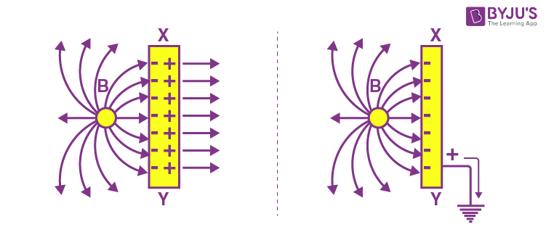

CAPACITANCE

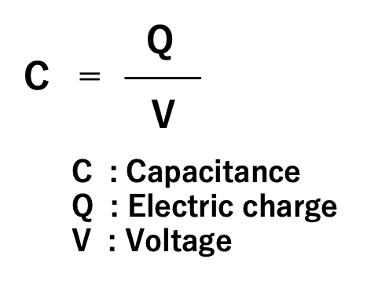is the ability of a system to **store electrical charge** when a potential difference (voltage) is applied across its components

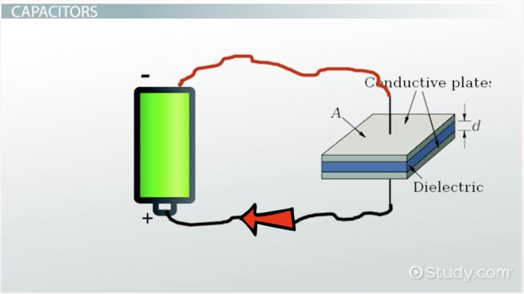

SERIES AND PARALLEL CIRCUITS

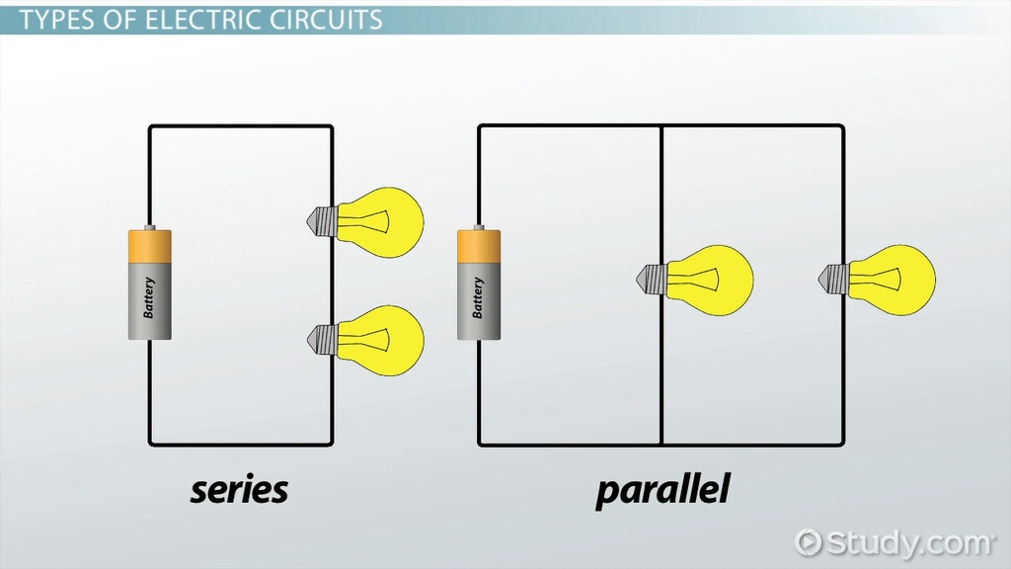

Series circuit, components are connected **end-to-end** in a single path, so the same current flows through all components.

Parallel circuit, components are connected across the same two points, providing multiple paths for current to flow.

PARALLEL CIRCUIT AND OVERLOADING

A **parallel circuit** provides multiple pathways for current to flow by connecting components across common points. While parallel circuits are advantageous in many applications, they are prone to **overloading** if not designed or managed correctly.

**Overloading** occurs when the total current drawn by the circuit exceeds the capacity of the power source or the wiring, potentially causing overheating, damage to equipment, or even fire hazards.

